**Lab Test-1**

**15-11-2023y**

**Name: Naga Tharun Makkena**

**Roll No: SE20UCSE105**

Q1. Write a program that performs four fundamental arithmetic operations on two variables within a distributed system.

**Code:**

**Arithmetic.idl**

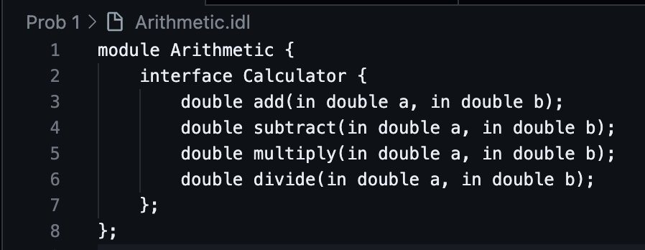

**CalculatorImpl.java**

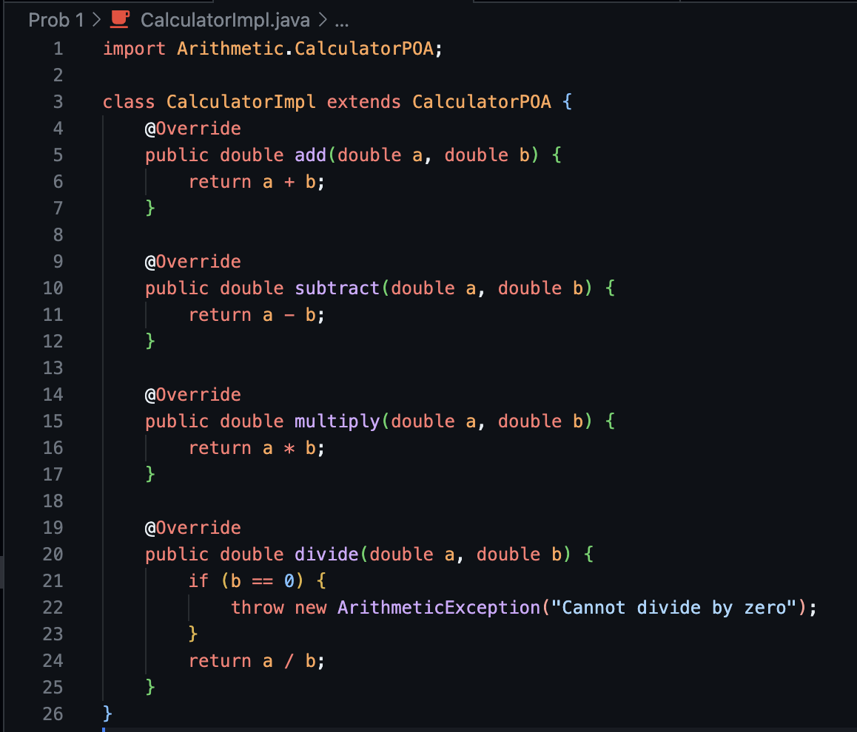

**Server.java**

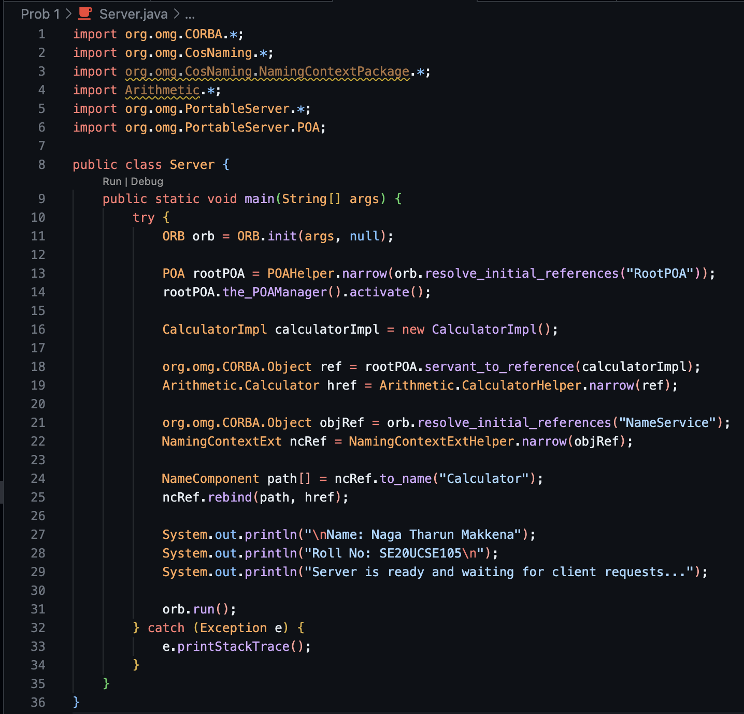

**Client.java**

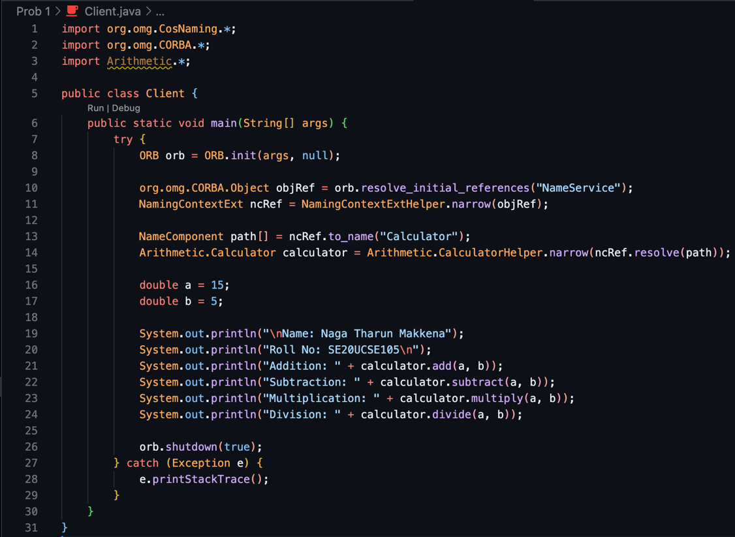

**Output:**

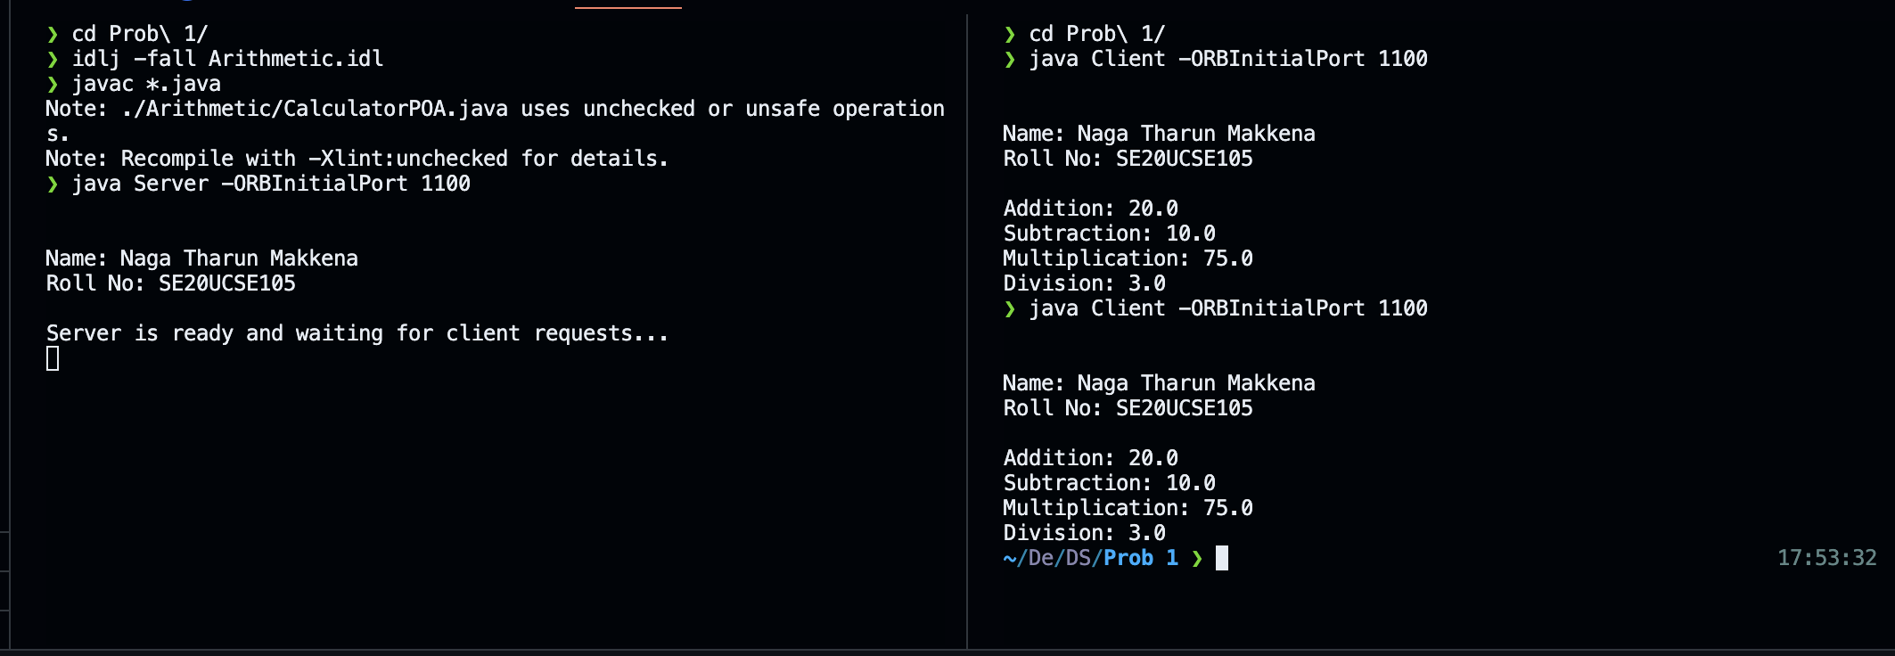

Q2. Develop a server-client application based on Remote Procedure Call (RPC).

**Code:**

**Server.java**

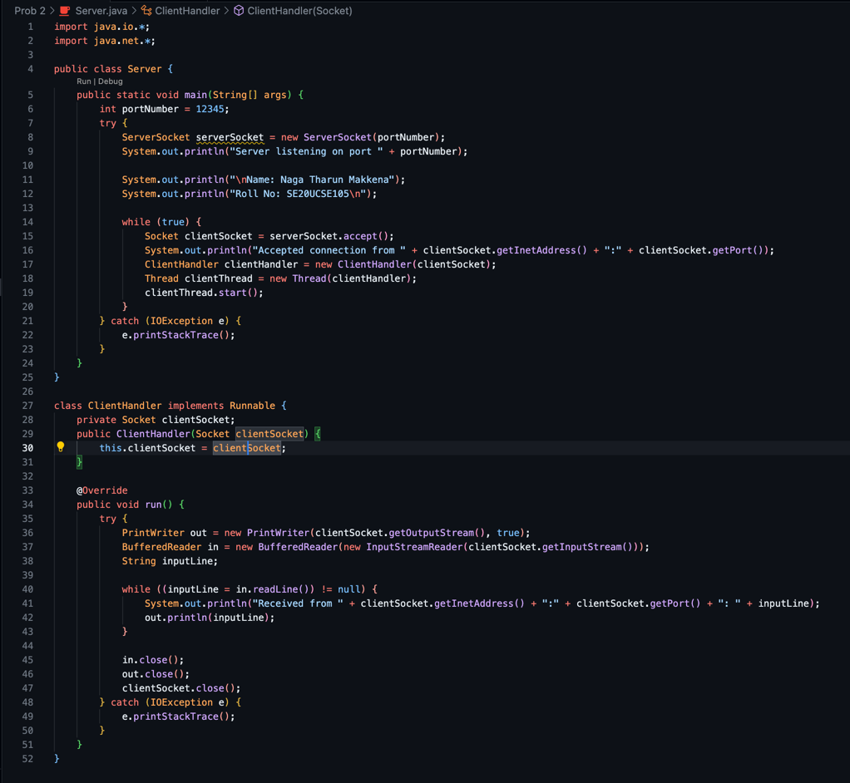

**Client.java**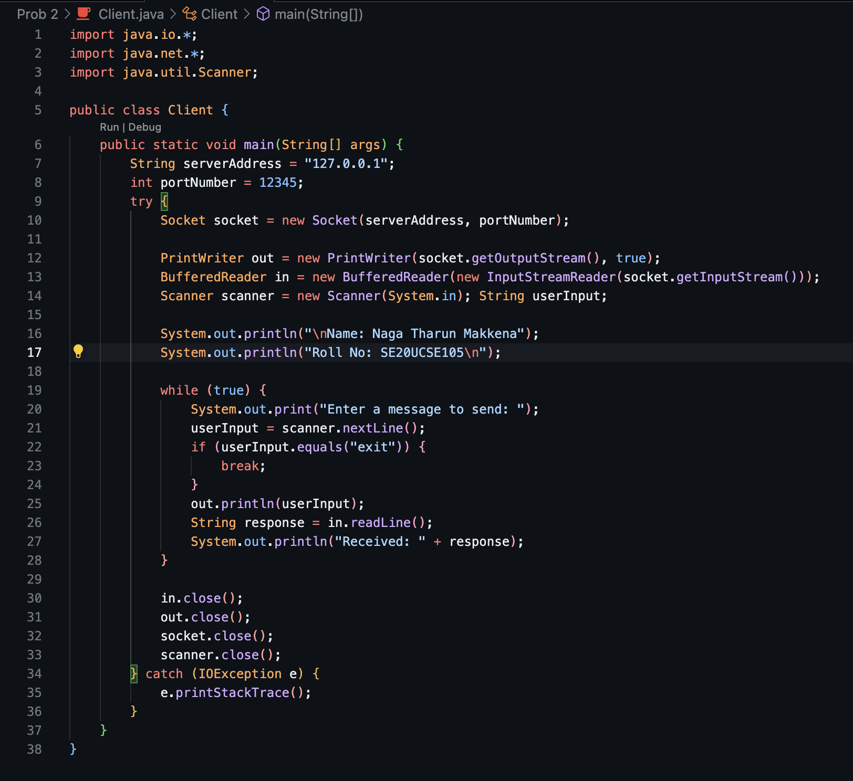

**Output:**

